**Report on RDK-B**

**Aim :**  The aim is to bring RDK on RPi and to build a custom interface.

**Required Devices :** RPi 4, Client machine ( can be any laptop), Display monitor, WAN internet source, SD card, keyboard.

**Procedure :**

1. First download the RDK-B image using linux terminal with following commands.
2. sudo apt install python3-is-python3
3. mkdir rdkb  
   cd rdkb
4. sudo snap install git-repo
5. -> mkdir ~/bin  
   ->export PATH=~/bin:$PATH  
   ->sudo apt install curl  
   -> curl <http://commondatastorage.googleapis.com/git-repo->downloads/repo>~/bin/repo
6. sudo apt install git
7. git init
8. git config –global user.email “[you@example.com](mailto:you@example.com)”  
   git config –global user.name “Your Name”
9. Vim .netrc
   1. repo init -u <https://code.rdkcentral.com/r/rdkcmf/manifests>-m rdkb-extsrc.xml -b rdkb-2022q2-dunfell
10. sudo apt-get update  
      
    sudo apt-get -y install libtiff5-dev libtiff5 liblzo2-dev uuid-dev bison flex libc6:i386 libstdc++6:i386 libc6-dev-i386 bzip2 make vim-common automake build-essential pkg-config dos2unix bc gawk libtool python python-six git python3 openvswitch-switch dropbear-bin ncurses-dev ccache hexec python3-pip quilt wget unzip libssl-dev libncurses5-dev lzma-dev liblzma-dev lzma binutils-dev autoconf autotools-dev bsh g++ gettext bisonc++ zlib1g-dev
11. Sudo apt-get install gawk wget git-core diffstat unzip texinfo gcc  
    -multilib build-essential chrpath socat cpio python3 python3-pip  
    Python3-pexpect xz-utils debianutils iputils-ping python-git python3-jinja2 libegl1-mesa libsdl1.2-dev pylint3 xterm
12. repo sync -j `nproc` –no-clone-bundle –no-tags.

2) After installing, Download “ Balena Etcher “. This software is used to flash the image on sd card.

3) For flashing you have to open the Balena Etcher and browse the image.  
  
Pathway for image : rdkb ( where you install rdkb ) -> build raspberryPi-rdk-broadband -> tmp -> deploy -> images -> raspberryPi-rdk-broadband -> ( file with size around 80 Mb and .wic extension).

4) Start flashing image and after flashing remove the sd card and put it into RPi and start booting making all the connections.

5) Connection diagram :

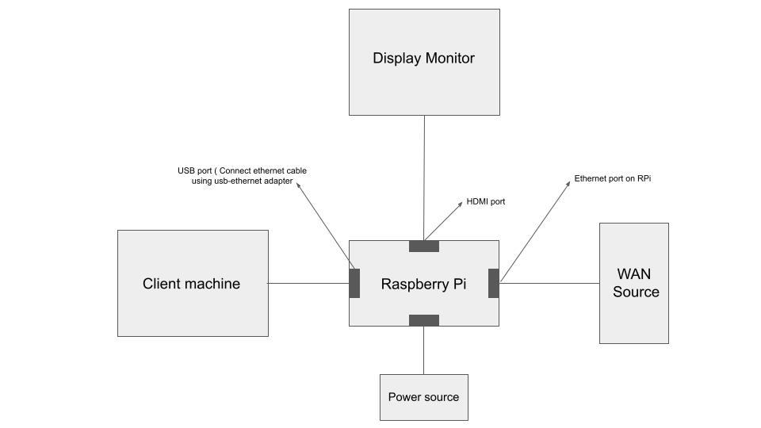

6) After flashing the image enter the user name as root and login. Try “ ifconfig ” command and get all the interfaces.

7) Try to ping the gateway from your client machine ( laptop ) using the IP of eth 0 or eth 1. In case if you are not able to find the IP of eth interface or ping is not happening.

8) first check the connections and then connect one keyboard to the RPi and type the command if eth0 is there “ brctl addif brlan0 eth0” or if eth1 is there then “brctl addif brlan0 eth1 “

What this command will do it will add eth interface under brlan0 whose ip is known. So we can access or connect to eth interface via brlan0 IP.

9) After successful pinging try to access the WEB UI by typing the IP address 10.0.0.1 in the chrome window.

**Observations :**

After successful connections your webUI will looks like this :

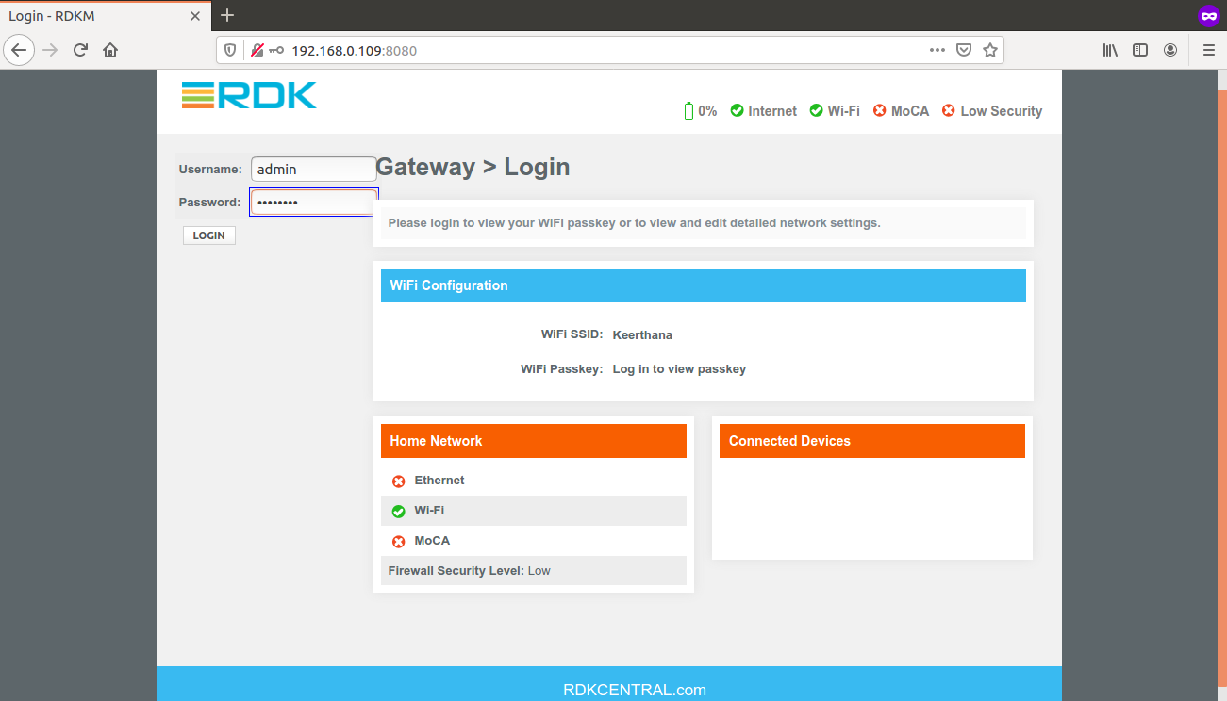

**Issues :**

Some time due to network connection there can be some issues with UI. It will show some RDKM interface which ask you to create custom wifi name and password. But after so many attempts some time you will not be able to figure it out. It will looks like these.

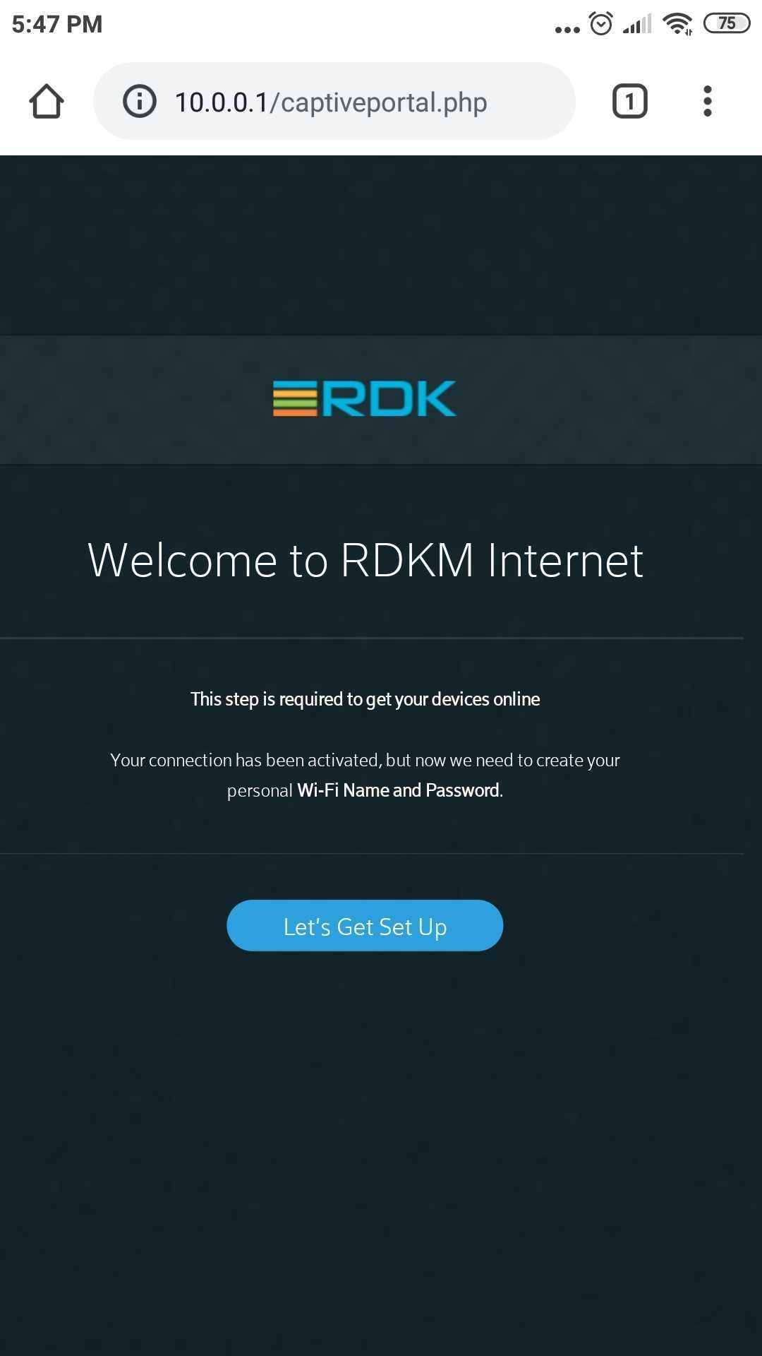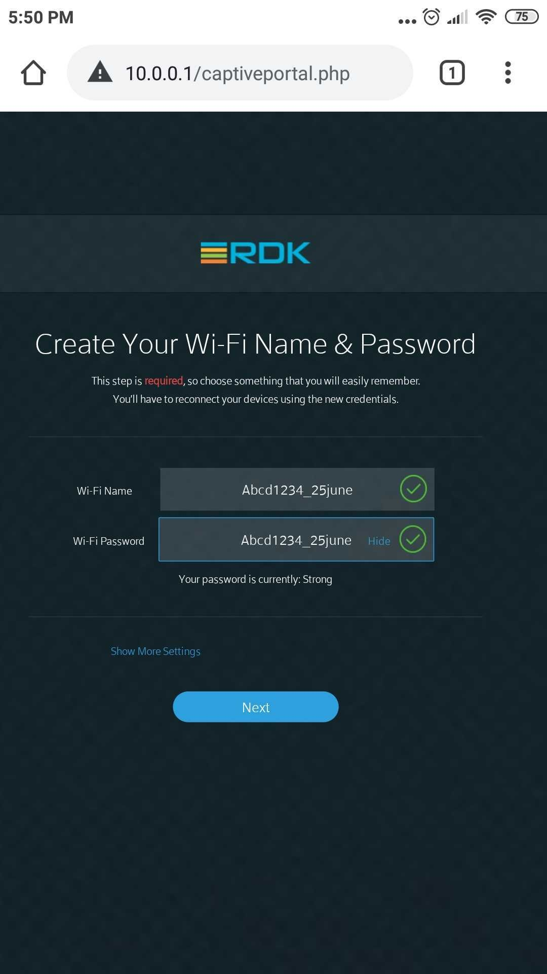

So to resolve this first remove all the connection and fix it again. Check your network strength. Try some dmcli commands which can fix and also you can check that image flashed correctly. If not with these steps then you have to reflash your image in that.

**Some dmcli commands :**

Syscfg update

Syscfg get PartnerID

‘ It should return RDKM in next line’.

**dmcli simu getv Device.DeviceInfo.X_RDKCENTRAL-COM_Syndication.RDKB_UIBranding.**

**dmcli simu getv Device.DeviceInfo.X_RDKCENTRAL-COM_Syndication.**